**ASSIGNMENT - 5**

**Firewall and VPN – Simple Summary:**

A **firewall** is like a security guard for your computer or network. It checks all the data coming in and going out, and blocks anything suspicious or harmful. This helps protect your system from hackers, viruses, and other online threats.

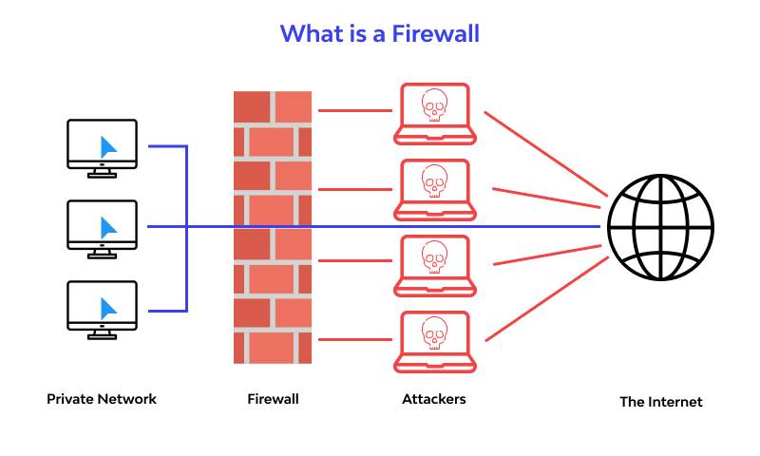

A **VPN (Virtual Private Network)** is like a secret tunnel for your internet connection. It hides your real location and keeps your data private by encrypting it. This means no one can see what you're doing online, even when you're using public Wi-Fi.

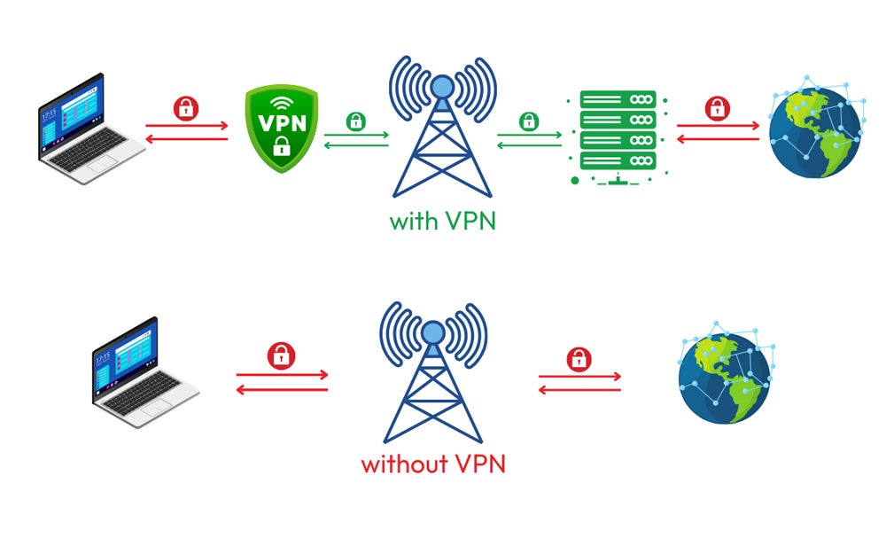

**In short:**

* A **firewall** keeps bad things out of your system.
* A **VPN** keeps your online activity private and secure.